Week 1

Design principles & Patterns

Exercise 1: Implementing the Singleton Pattern
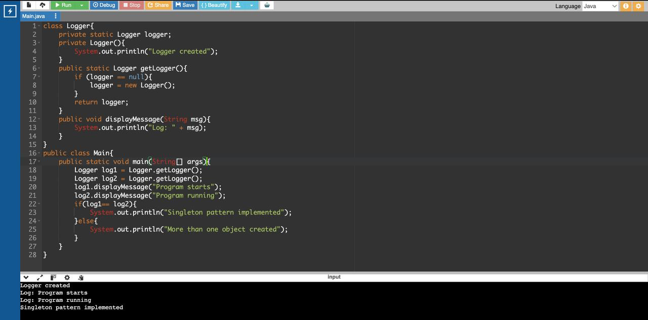

Exercise 2: Implementing the Factory Method Pattern

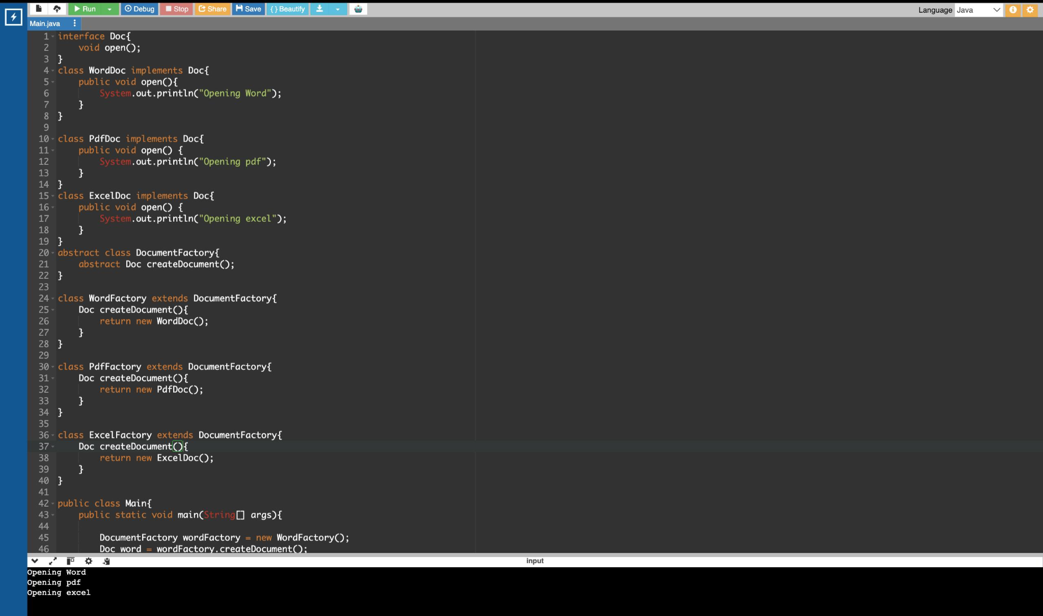
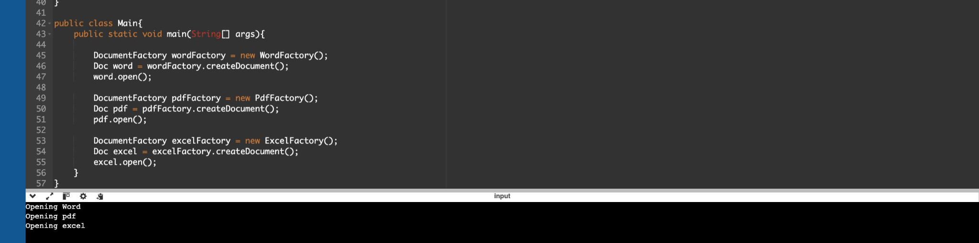

Data structures and Algorithms

Exercise 2: E-commerce Platform Search Function
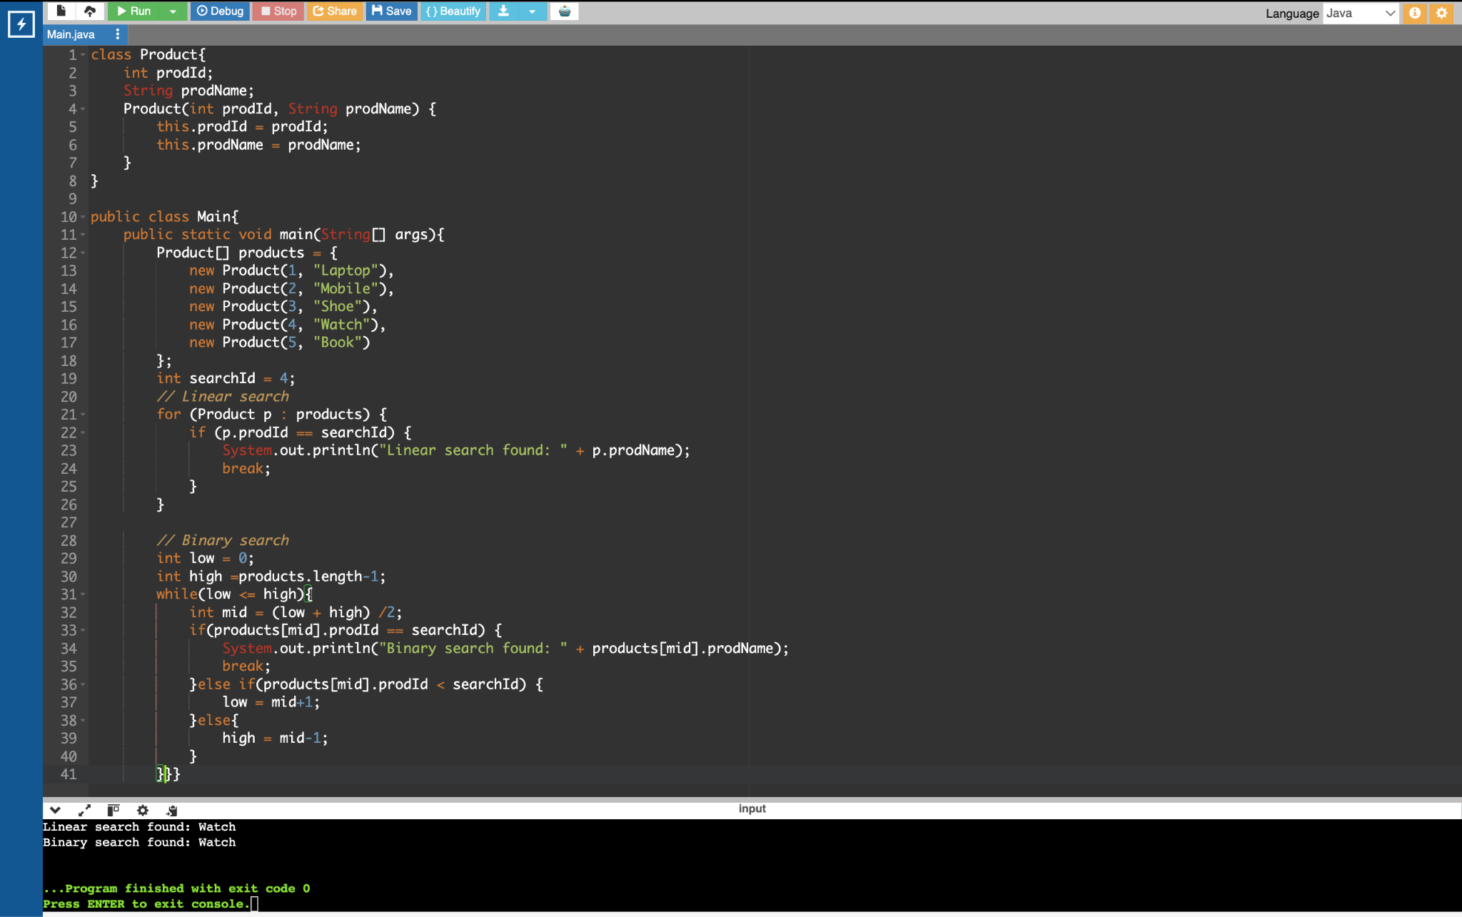
Big O notation is used to measure the efficiency of an algorithm by telling us how the run time increases as the amount of data increases.
Time complexity:
Linear search : Best case: O(1) Avg case: O(N) Worst case: O(N)
Binary search: Best case: O(1) Avg case: O(logN) Worst case: O(logN)
Reasoning: Binary search is time efficient for a usecase like e commerce platform due to listing of more products whereas Linear seach is slower as products count increases
Exercise 7: Financial Forecasting

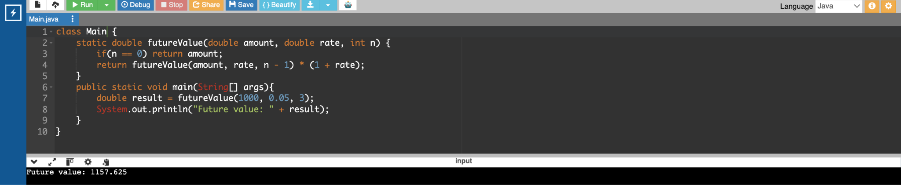
Recursion is a technique when a function calls itself until a condition is satisfied.
TIme complexity: O(N)

PL/SQL programming

Exercise 1: Control Structures
Scenario 1:

BEGIN
FOR c IN(SELECT CustomerID, Age, InterestRate FROM Customers)
LOOP
IF c.Age > 60 THEN
UPDATE Customers
SET InterestRate = InterestRate - 1
WHERE CustomerID = c.CustomerID;
END IF;
END LOOP;
END;
/

Scenario 2:

BEGIN
FOR c IN (SELECT CustomerID, Balance FROM Customers)
LOOP
IF c.Balance > 10000 THEN
UPDATE Customers
SET IsVIP = 'TRUE'
WHERE CustomerID = c.CustomerID;
END IF;
END LOOP;
END;
/

Scenario 3:
BEGIN
FOR l IN (
SELECT CustomerID, DueDate
FROM Loans
WHERE DueDate <= SYSDATE+30
)
LOOP
DBMS_OUTPUT.PUT_LINE(
'Reminder: Loan due for Customer ID '|| l.CustomerID);
END LOOP;
END;
/

Exercise 3: Stored Procedures
Scenario 1:

DELIMITER //
CREATE PROCEDURE ProcessMonthlyInterest()
BEGIN
UPDATE accounts
SET balance = balance*1.01
WHERE account_type= 'savings';
END //
DELIMITER ;
CALL ProcessMonthlyInterest();

Scenario 2:

DELIMITER //
CREATE PROCEDURE UpdateEmployeeBonus(
IN p_department_id INT,
IN p_bonus_percentage DECIMAL(5, 2)
)
BEGIN
UPDATE employees
SET salary = salary +(salary * p_bonus_percentage/100)
WHERE department_id =p_department_id;
END //
DELIMITER ;
CALL UpdateEmployeeBonus(3, 10.00);

Scenario 3:

DELIMITER //
CREATE PROCEDURE TransferFunds(
IN from_account_id INT,
IN to_account_id INT,
IN amount DECIMAL(15,2)
)
BEGIN
DECLARE sender_balance DECIMAL(15,2);
SELECT balance INTO sender_balance
FROM accounts
WHERE account_id =from_account_id;
IF sender_balance < amount THEN
SIGNAL SQLSTATE '45000' SET MESSAGE_TEXT = 'Insufficient funds';
ELSE
UPDATE accounts SET balance = balance-amount WHERE account_id = from_account_id;
UPDATE accounts SET balance =balance+amount WHERE account_id = to_account_id;
END IF;
END //
DELIMITER ;

CALL TransferFunds(1, 2, 500.00);

